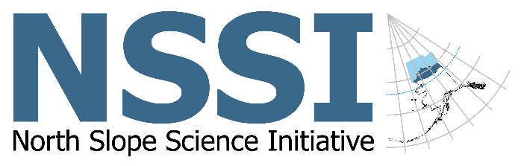

North Slope Science Initiative
Science Technical Advisory Panel
Nomination Form
Nominee's Full Name:
Occupation/Title:
Company/Organization (if applicable):
Mailing Address:

E-mail Address:
Phone:
Education (colleges, degrees, major field of study):

Membership Criteria: The Science Technical Advisory Panel shall consist of a representative group of not more than 15 scientists and technical experts from diverse professions and interests, including the oil and gas industry, subsistence users, Alaska Native entities, conservation organizations, and academia, as determined by the Secretary of the Interior. Nominees must have a minimum of five (5) years of experience in the Arctic in their field of expertise. Members will be selected to exercise their own individual best judgment on behalf of the Federal Government based on their technical expertise in one or more of the following areas: North Slope traditional and local knowledge, landscape ecology, petroleum engineering, civil engineering, geology, botany, hydrology, limnology, habitat biology, wildlife biology, restoration science, biometrics, sociology, cultural anthropology, economics, ornithology, oceanography, fisheries biology, climatology, or other relevant areas of expertise.

Experience highlights (significant experience, civic and professional activities, elected offices, or achievements related to the interest to be represented or the technical expertise to be provided; attach additional pages as necessary, but DO NOT submit lists of publications):

Experience working with disparate groups to achieve collaborative solutions (e.g., prior advisory committees, civic organizations, planning commissions, school boards, etc.):

Experience or knowledge of the North Slope of Alaska:

Specific area(s) of expertise (check no more than two):

___ North Slope Traditional and Local
Knowledge

___ Cultural Anthropology

___ Sociology

___ Economics

___ Landscape Ecology

___ Botany

___ Limnology

___ Habitat Biology

___ Wildlife Biology

___ Restoration Science

___ Fisheries Biology

___ Ornithology

___ Biometrics

___ Civil Engineering

___ Petroleum Engineering

___ Hydrology

___ Marine Ecology

___ Marine Mammals

___ Oceanography

___ Climatology

Other, please identify:_________________

Indicate the nominee’s direct or indirect interests in leases, licenses, permits, contracts, or claims involving lands or resources administered by the Bureau of Land Management:

MAIL or FAX COMPLETED NOMINATION FORM (address and FAX number below) with at least one reference letter from someone knowledgeable of the nominee’s technical expertise. A reference letter is required. References also may send letters directly to the address or FAX number below.

Nominated by (if applicable, include name, address, and telephone – leave blank if self-nominated):

PRIVACY ACT STATEMENT
The authority to request this information is contained in 5 U.S.C. 301, the Federal Advisory Committee Act, and Part 1784 of the Title 43, Code of Federal Regulations. It is used by the appointment officer to determine education, training, and experience related to possible service on an advisory council of the Bureau of Land Management. If you are appointed as an advisor, the information will be retained by the appointing official as long as you serve. Otherwise, it will be destroyed 2 years after termination of your membership or returned (if requested) following announcement of council appointments. Completion of this form is voluntary. However, failure to complete any or all items will inhibit fair evaluation of your qualifications, and could result in you (or your nominee) not receiving full consideration for appointment.

Nominee Signature: _______________________________________

Date: ____________________

Mail or FAX completed form(s) to:

North Slope Science Initiative
c/o Bureau of Land Management
222 West Seventh Avenue, #13
Anchorage, AK 99513-7504
FAX: 907-271-4596

The deadline for the NSSI to receive all public nominations/applications for membership on the panel is November 24, 2017.

